TRAINING HISTORY QUESTIONNAIRE
Section 1
Please complete this questionnaire thoroughly as your answers will help us provide you with the best exercise training program specific to your goals.

Email address*

Section 2
CARDIO TRAINING
You will be asked various questions about your cardio programming over the last three months in order to better understand your recent cardio training history. Cardio is a continuous steady-state exercise completed at a low to medium intensity for > 30 minutes.

Adhering the description of cardio training provided above, in the last 3 months how many times per week (on average) have you completed cardio training?

None

1-2x/week

3-4x/week

4+x/week

Other

What type of cardio training do you perform regularly (select all that apply)?

Running

Cycling

Swimming

Rowing

Assault bike

Elliptical

Stairmaster

Not Applicable

Other

What is the average duration of your cardio sessions?
Answer:

If you use zones, in what zone do you complete your cardio training? Check all that apply.

Zone 1
Zone 2
Zone 3
Zone 4
Zone 5
Not Applicable

Other

Using the RPE scale below, what is the average intensity of your cardio training?

2-3 Light

4-5 Moderate

6-7 Vigorous

8-9 Very hard

10 Max effort

N/A

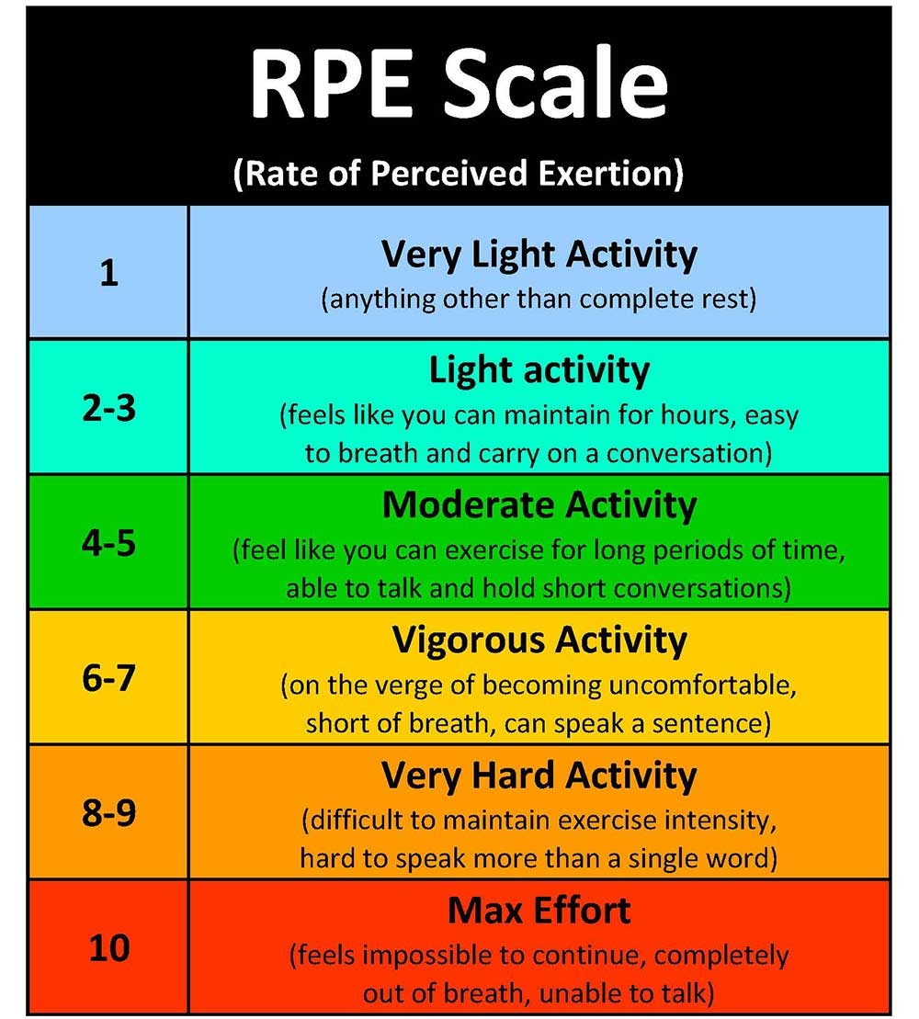

Section 3
INTERVAL TRAINING

You will be asked various questions about your interval training programming over the last three months in order to better understand your recent interval training history. Intervals are periods of medium or high-intensity exercise followed by relative rest completed multiple times in a session.

Adhering to the description on interval training provided above, in the last 3 months how many times per week (on average) did you complete interval training?

None

1-2x/week

3-4x/week

4+x/week

Other

What type of interval training do you regularly perform? (select all that apply)

Running

Cycling

Swimming

Rowing

Assault bike

Elliptical training

Stairmaster

Circuit training
N/A

Other

If you use zones, in what zone do you complete your interval training? Check all that apply.

Zone 1
Zone 2
Zone 3
Zone 4
Zone 5

N/A

Other

Using the RPE scale shown above, what is the average intensity of your interval training?

2-3 Light

4-5 Moderate

6-7 Vigorous

8-9 Very hard

10 Max effort

N/A

Section 4
RESISTANCE TRAINING
Resistance training is any exercise that causes the muscles to contract against an external resistance with the expectation of increases in strength, power, hypertrophy, and/or endurance.

How long have you been training using resistance/weights?

This will be my first time doing resistance training

Less than 1 year

1 to 2 years

2 to 3 years

3 to 5 years

5+ years

Other

Adhering the description of resistance training provided above, in the last 3
months, how many times per week (on average) have you completed resistance training?

None

1-2x/week

3-4x/week

4+x/week

Other

Using the Resistance RPE scale shown below, what is the average intensity of your resistance training?

5.5 - 7 - Light

7.5 or 8 - Moderate

8.5 or 9 - Heavy

9.5 or 10 - Maximal

N/A

Other

Resistance training RPE
